**NM ASSIGNMENT**

NM ID: [810C33127AF97FFBC87478114CEA8F62](https://naanmudhalvan.tn.gov.in/reports/dashboard/student/detail/810C33127AF97FFBC87478114CEA8F62/)

NAME: ANURAJ KISHORE J

1.Website using WordPress

Link: <https://myfood154.wordpress.com>

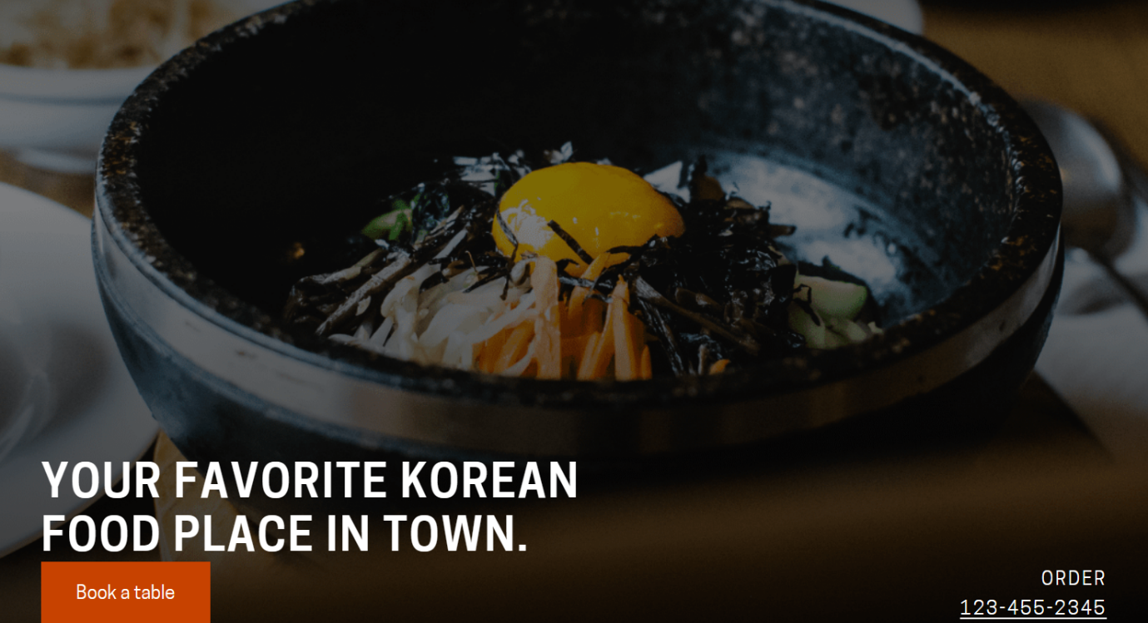

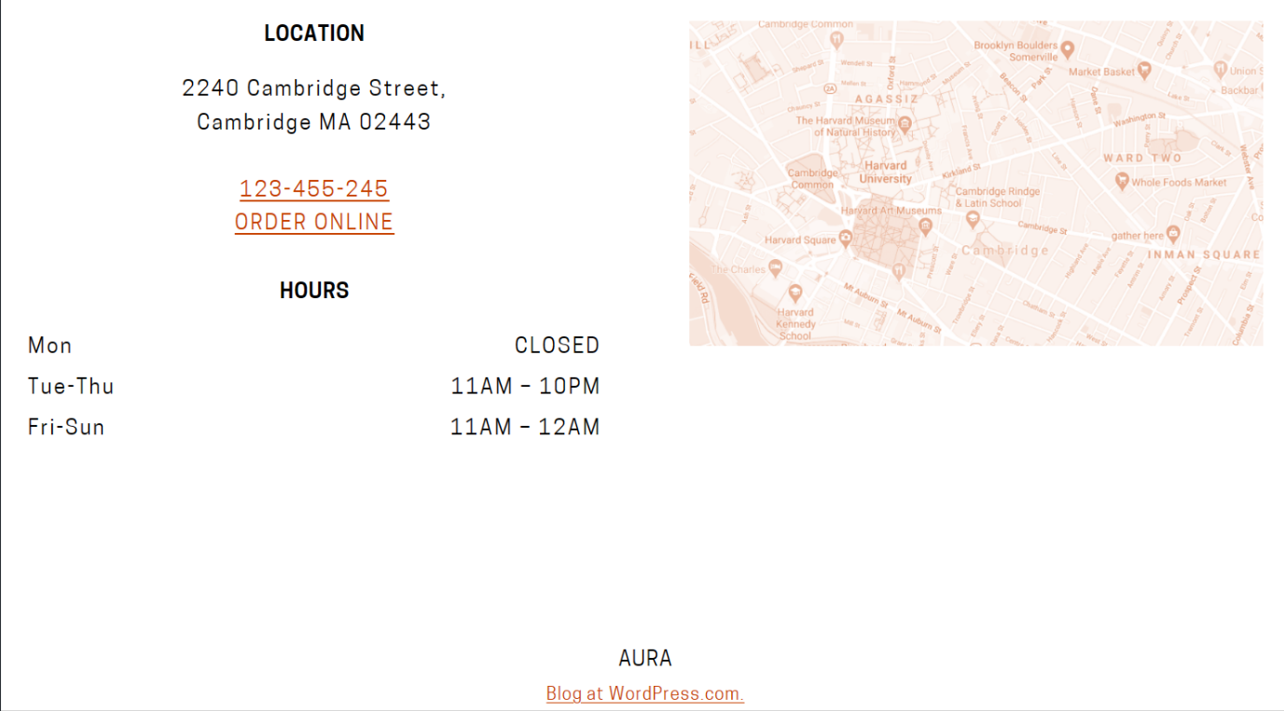

2.Create a new Facebook business page and post one social media poster for your brand.

Link: <https://www.facebook.com/profile.php?id=61552547063351&mibextid=ZbWKwL>

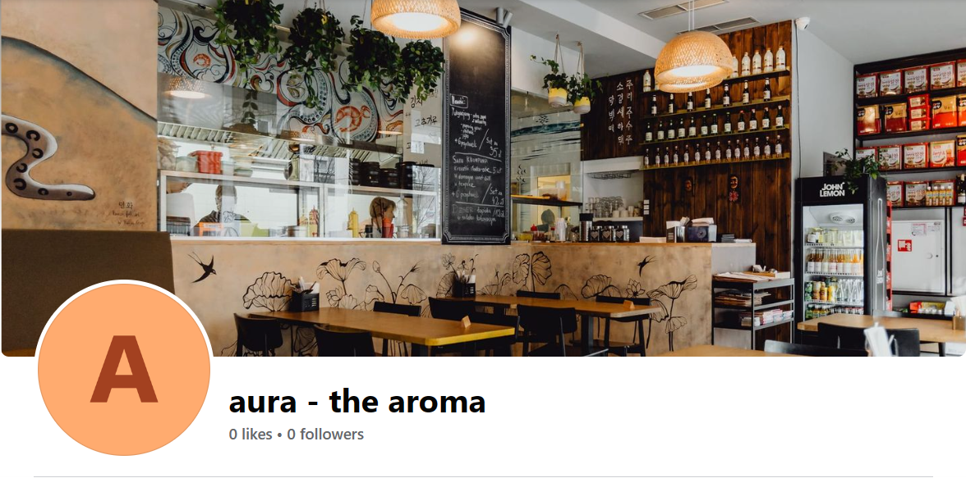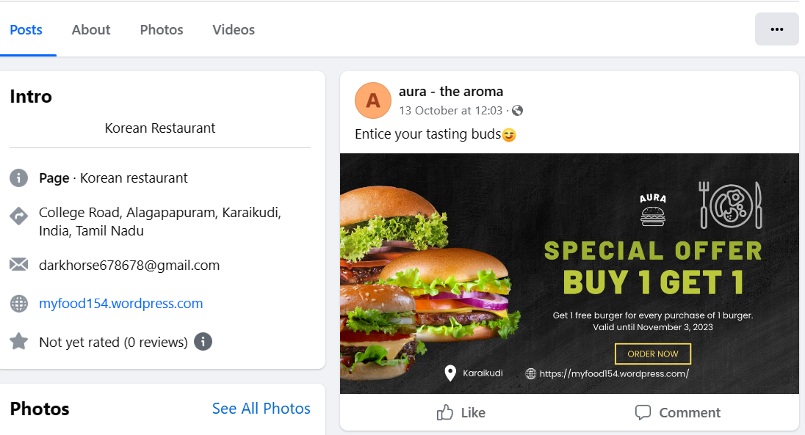

3.Create and design a social media advertisement poster using Canva

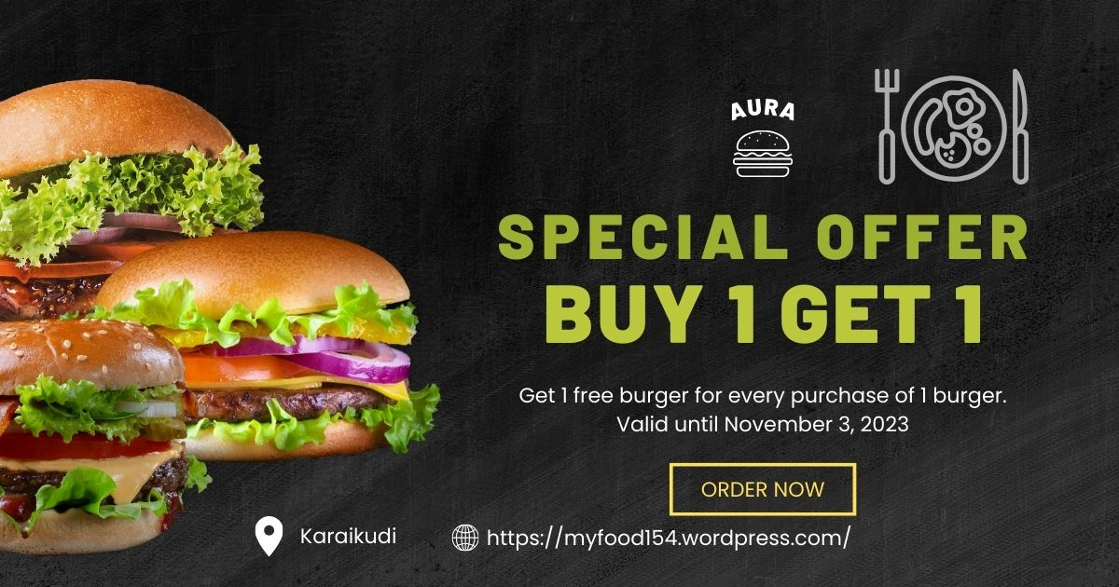

4.Create email newsletter design using Mailchimp or Canva tool.

